What IT Geeks needed to know in 2020?

The data will tell you what you should know by Stack Overflow’s developer survey data from 2020.

**Introduction**

You maybe already a geek in IT field, or getting ready to enter to this field. I believe you have got so many questions about that. What language is the hottest to learn? What are other IT geeks thinking? Do I prepare myself to keep chasing new technologies in my working life?

For answering these questions, I made an analysis based on Stackoverflow’s 2020 developer Survey to give you some hints.

This survey consists of sixty questions and around 60,000 respondents, like:

[

What is your age?

Which programming, scripting, and markup languages have you done extensive development work in over the past year?

How frequently would you say you visit Stack Overflow?

]

In the following, I prepared THREE questions to ask. And they will be answered by the data of Stackoverflow’s 2020 developer Survey. They are:

1. What are top FIVE hottest programming languages in 2020?

2 What kind of people would like to keep studying new techologies?

3. How could Stack Overflow segment their visitors according their behaviours on the platform?

**Question 1 – What are top FIVE hottest programming languages in 2020?**

I believe you, may or may not be an IT geek, should want to know what are the hottest programming languages in 2020? Is the programming language of my working hottest one? Let me show you:

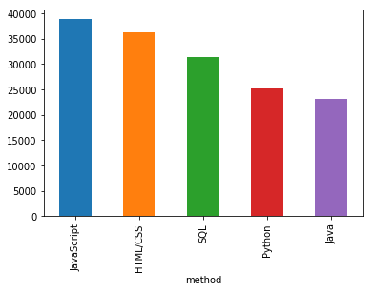

After analysis on result of survey, the top 5 programming languages used by most participants to work with are:

1. JavaScript
2. CSS/HTML
3. SQL
4. Python
5. Java

Is the programming language you are working one of them? If so, congratulation. If not, you will have to consider to pick up one.

**Question 2 – What kind of people would like to keep studying new technologies?**

In this question, we targeted an attribute of the survey called “How frequently do you learn a new language or framework?”. It shows four options to respondents. They are:

1. Once a decade.
2. Once every few years.
3. Once a year.
4. Every few months.

This diagram shows the populations for these four options:

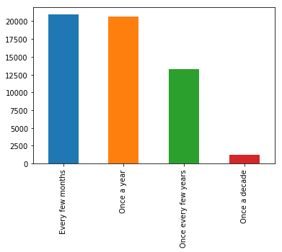

Then we took three aspects below to find the relationships between frequency of learning new language and them:

First, let’s see the relationship between frequency of learning new language and respondents’ current job-seeking status:

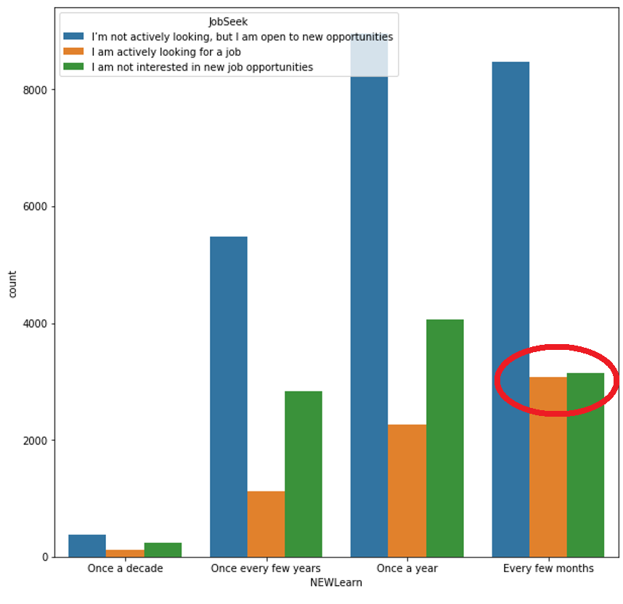

We can see that if the people do not frequently learn new programming language, most of them are not actively looking for job.

However, if the people frequently learn new programming language, like every few months, more of them are actively looking for job.

Second, let’s see if there is relationship between age and frequency of learning new language.

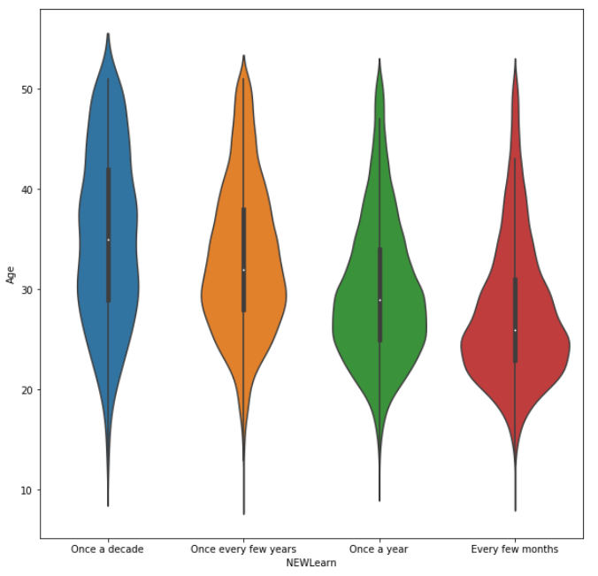

For the people do not frequently learn new programming language, they are generally order. And people frequently learn new programming language, like every few months, they are younger.

Thirdly, let’s compare the frequency of learning new language and if people code as hobby.

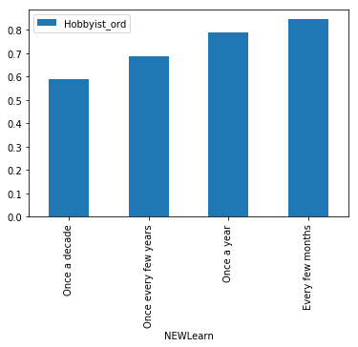

For the people do not frequently learn new programming language, they do not code as hobby so much. And people frequently learn new programming language, like every few months, most of them code as hobby.

**Question 3 – How to describe the visitors of StackOverflow and how to segment them?**

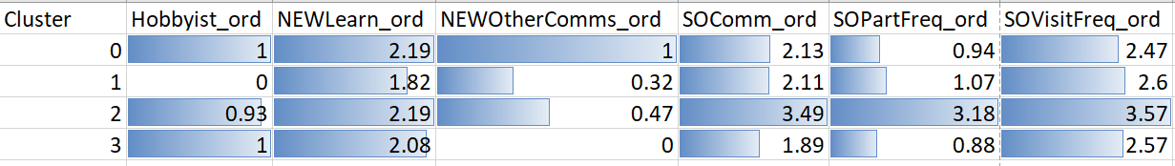

**Cluster 0 - IT Geek but not tied to Stack Overflow**

People in this group are hobbyist in coding. They all have membership on any other online developer communities (average of NEWOtherComms is 100%). But they just visit Stack Overflow and participate in Q&A sometimes. Seems they don't like Stack Overflow pretty much, or maybe they like the alternative developer communities more.

**Cluster 1 - Not IT geek at all**

People in this group are not hobbyist in coding at all. They don't often learn new technologies. And most of them don't have other online developer communities (only 32% of them have that). They usually visit Stack Overflow but not do so for answering Q&A. Seems they work in this field only for salary. They are not interested in IT or coding.

**Cluster 2 - Stack Overflow super fans**

People in this group are the most favourite geeks for Stack Overflow. They are geek because most of them are coding hobbyist, and half of them have membership on any other online developer communities. But that's not a big deal, most of them visit Stack Overflow and participate in Q&A daily. They also treat themselves as member of Stack Overflow community.

**Cluster 3 - Stack Overflow fans with read-only**

People in this group are geek and fans for Stack Overflow. They don't have membership on any other online developer communities at all. They keep usually visiting Stack Overflow. However, they don't often participate in Q&A. Seems they visit Stack Overflow for just getting what they want to know.

**Conclusion**

In the analysis above, we took a look at some IT geeks’ behaviors about IT and Stack Overflow itself by Stack Overflow survey 2020.

1. From the question of survey about which programming, scripting or markup languages used for working, we got that “JavaScript” is the hottest language followed by “Python” in 2020.
2. After looking at hottest programming language, we saw that the factors of people who keep learning new programming languages are:
   1. Actively looking for a job.
   2. Younger in age.
   3. Code as hobby.
3. Finally, we wanted to know more about what characteristics of IT geeks on Stack Overflow look like. we applied a clustering analysis and got four types of people, they are:
   1. **IT Geek but not tied to Stack Overflow**
   2. **Not IT geek at all**
   3. **Stack Overflow super fans**
   4. **Stack Overflow fans with read-only**

What about you, IT geek?